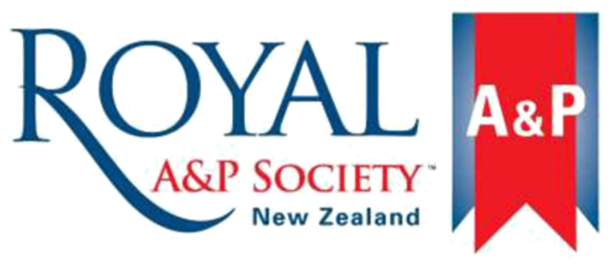

Health and Safety Manual

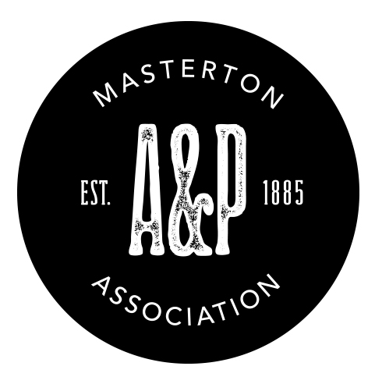

Health and Safety Manual

CONTENTS

Introduction
Policy and Objectives
Health and Safety at Work Act 2015
Show Rules
Definitions

Elements of Health and Safety Management
Hazard and Risk Management
Incident Reporting and Investigation
Emergency Plan
Evacuation Procedures
Participation and Leadership
Review and Audit
Show/Event Plan
Information, Training and Supervision
Contractors, Visitors and Other Persons
Smoke-Free Working Environment
First Aid

Section 1
Introduction

Policy and Objectives

Policy

The Masterton A&P Association recognises their responsibilities to maintain the health, safety and well-being of everyone involved in their activities, attending their competitions, and who uses their Showgrounds and facilities. They are committed to the management of hazards and risks and ensuring positive safety outcomes for all. The committee will:
- Aim to avoid harm
- Continually learn and improve their practices
- Ensure appropriate policies and procedures are in place and implemented
- Ensure that hazards and risks are identified, documented and controlled
- Review incidents and investigate them where appropriate
- Apply emergency management processes
- Prepare a Show or Event Plan
- Ensure chemicals, plant and equipment are purchased, used and maintained in line with manufacturer’s instructions and best practise
- Ensure buildings and facilities are designed, built, used, maintained and dissembled with due regard for safety
Purpose
This section lists the objectives of the health and safety manual.
Objectives

The Masterton A&P Association health and safety programme aims to:
• promote excellence in health and safety management
• continually improve health and safety performance
• provide a safe and healthy Showgrounds and show
• identify and control actual and potential hazards and risks
• establish and maintain communication on health and safety, including with contractors, hirers and the public
• support participation in health and safety matters
• identify needs and provide training on health and safety
• demonstrate a commitment to the accurate reporting and recording of health and safety matters
• comply with legal and organisational obligations

Objectives will be achieved through:
• both the committee and the management’s support and commitment to health and safety
• implementation of relevant policies and procedures
• implementation of an annual Show Plan
• staff and volunteer education and participation
• regular reviews and evaluations

Health and Safety at Work Act 2015

Purpose
This section provides a brief summary of the health and safety legislation and defines accountabilities.
Purpose of the Health and Safety at Work Act 2015
A guiding principle of the Health and Safety at Work Act 2015 (HSWA) is that workers and all other persons should be given the highest level of protection against harm to their health, safety, and welfare from work risks as is reasonably practicable.
The main purpose of HSWA is to provide for a balanced framework to secure the health and safety of workers and workplaces.
Other people who have duties under the Act include persons in control of places of work; self-employed people; principals to a contract; contractors and subcontractors; and staff members.
Duty Holders under HSWA
A duty holder is a person who has a duty under HSWA. There are four types of duty holders – PCBUs, officers, workers and other persons at workplaces.
PCBU
A PCBU is a ‘person conducting a business or undertaking’. A PCBU may be an individual person or an organisation.
A PCBU must ensure, so far as is reasonably practicable, the health and safety of workers, and that other persons are not put at risk by its work. This is called the ‘primary duty of care’.
Officer
An officer is a person who occupies a specified position or who occupies a position that allows them to exercise significant influence over the management of the business or undertaking. This includes for example, the boss of a company.
Officers must exercise due diligence to ensure the PCBU meets its health and safety obligations.
Worker
A worker is an individual who carries out work in any capacity for a PCBU. A worker may be an employee, a contractor or sub-contractor, an employee of a contractor or sub-contractor, an employee of a labour hire company, an apprentice or a trainee, a person gaining work experience or on a work trial, or a volunteer worker. Workers can be at any level (e.g., managers are workers too).
Workers have their own health and safety duty to take reasonable care to keep themselves and others healthy and safe when carrying out work.
Other persons at workplace
Examples of other persons at workplaces include workplace visitors and casual volunteers at workplaces.
Other persons have their own health and safety duty to take reasonable care to keep themselves and others safe at a workplace.

Show Ground Rules

Purpose
This section identifies the “non-negotiable” rules of Masterton A&P Association that help ensure a safe Showgrounds and show.
Show and Ground Hire Rules for Masterton A&P Association
Watch out for each other — speak up if you think something is dangerous.

No untrained people to drive the show tractor.

Show speed limit is 10kph — no exceptions.

No horses or livestock in ‘no-go’ zones.

No children under 14 years old to drive quad bikes and helmets to be worn at all times of operation.

If its broken, fix or replace it (don’t use it broken)

Wear helmets, earmuffs and chaps when using a chain saw.

Only contractors with the appropriate skills, PPE and equipment are engaged.

Anyone using the Cross Country or Sand Arenas must notify the Manager that they will be using the course by either email or there on-line booking. They must wear all safety approved clothing including current safety vest and helmet.

Anyone riding on the grounds must bring a sort person with them that is capable of assisting in the event of an accident which involves being competent in dealing with the animal.

Any falls or hazards must be notified to events@theshowgrounds.nz

Definitions

Purpose
This section lists terms used in this manual and clarifies their meaning. Note an individual person or organisation may fit more than one category under the “people” heading”.
People

Staff

A person or persons employed by Masterton A&P Association on an employment agreement and paid for their work.

Volunteer

Any person involved in the management, organisation, preparation and conduct of the show and/or Showgrounds directly on behalf of Masterton A&P Association for no compensation in the form of salary or wages. A volunteer acts on a voluntary basis (whether or not the person receives out-of-pocket expenses).

Contractor

Any person, business or organisation providing service or services to Masterton A&P Association for payment on the basis of a contract for service, quote, agreement etc.

Visitor

Any person visiting a staff member, a volunteer or a contractor on site. They need to be escorted by the individual they are visiting at all times and advised of hazards and risks in the areas they visit.

Competitor

Any person or persons who have entered a show or event for the purposes of competition.

Trade Stall Holder; Entertainment Provider; Food Outlet

Any person, business or organisation at the show who has:
- taken a trade site (Trade Stall Holder)
- provides entertainment or amusements for the public either as a performer or by providing activities or amusements (Entertainment Provider)
- provides food (Food Outlet).

The above may / may not have a formal contract with Masterton A&P Association and may / may not make a payment to or receive a payment from Masterton A&P Association (or via a charge to the public). They may / may not have paid staff at the show. Note they may also meet the definition of a contractor.

Public

Any person or persons otherwise attending a show or event held on the Showgrounds of Masterton A&P Association. Members of the public must be assumed to have limited if any understanding of the hazards and risks they may encounter. Note a person may be a competitor in one section but meet the definition of a member of the public elsewhere on the showgrounds.

Hirer

Any person or organisation who hires, borrows or uses with permission (whether or not payment is exchanged) the Showgrounds or other property of Masterton A&P Association.

Terms used

Hazard

An actual or potential cause or source of harm or damage, including adverse health effects. A threat.

Risk

The potential impact of a given hazard. A combination of the potential likelihood and consequences of interacting with the threat.

Incident

An accident (where someone was harmed) or near miss (where no harm occurred).

Hierarchy of Controls

A list of control measures, to be considered in priority order, that is used to identify ways to eliminate or minimise exposure to the risk.

Showgrounds

The site of Masterton A&P Association’s annual show whether or not the site is owned, leased on an annual basis or provided for a limited period of time to set up, run and disassemble the show. Showgrounds include any area only available for set dates, whether that be the whole site or extra space for parking for example. Any area not available all year is only the responsibility of the organising committee on the dates they have possession of the site and this may be reflected in the controls selected for managing the risks in those areas.

Section 2
Elements of Health and Safety Management
Hazard and Risk Management

Purpose
To continually identify, assess and control hazards based on the proportional risk they pose.
Responsibilities

The Show Manager is responsible for:
• conducting site safety inspections
• maintaining the hazard register, including identification and risk analysis
• working with staff, volunteers and relevant contractors, hirers, trade stall holders, entertainment providers and food outlets to control identified hazards and risks
• contract specialists where available competency is insufficient to identify, eliminate or minimise hazards and risks

Staff; volunteers; contractors; hirers; trade stall holders; entertainment providers and food outlets are responsible for:
• implementing hazard and risk management procedures, including following safety rules and instructions
• taking all practicable steps to ensure that hazards and risks identified are eliminated or minimised in line with the hierarchy of controls, including any they introduce
• notifying the Show Manager of any hazard or risk they identify
• informing others of any hazards and risks to health and safety which are known to be associated with the work they perform and the steps to be taken to control any such hazard
• ensuring unsafe acts and unsafe conditions are appropriately addressed
Procedure

Hazard management steps include:
1. Identification – describe the hazard and state its location
2. Risk analysis – rate the risk the hazard poses
3. Control – recommend the control measure (eliminate or minimise as per the hierarchy of controls)
If difficulties are experienced in identifying, eliminating or controlling hazards, the Show Manager will engage an outside contractor with appropriate experience.

Hazard management needs to be completed:
• systematically for all areas and processes at regular intervals and prior to the show each year
• when an incident occurs, a check is needed to ensure hazards and risks are identified and their controls are adequate
• when a new process or piece of equipment is introduced
• if a new hazard is observed or reported

Step 1 – Identify hazards and their risks

Hazard and risk identification and management will be reviewed at least once per year prior to the show

Identify the actual or potential causes or sources of harm or damage on the Showgrounds, including those with adverse health effects – the hazards.

Once a hazard is identified determine how people might interact with it and the potential impact of an incident involving that hazard – the risk the hazard poses. One hazard may have several risks as there may be several ways to interact with it.

Hazards and the risks they pose are best identified by walking around the Showground, including inside all buildings, looking up, down and around. Hazards and risks may also be identified in:
- incident reports and investigations findings
- reviews and audits
- suggestions for improvement (observations)
- consideration of the hazards introduced by new structures, chemicals, plant or equipment. This assessment should be undertaken as part of the design process for any structures and purchase decisions. It should be reviewed again prior to initial use.
- consideration of all the activities involved in setting up, running and disestablishing the Showgrounds for the show
- the introduction of new competitions (including sections, classes, new types of animal); trade stalls; food outlets or entertainment providers. These must be reviewed for new hazards and risks, and how they may be controlled, before confirming the decision to include them in the show.
- The activities of contractors, hirers, trade stalls, food outlets or entertainment providers to undertake work on the Showgrounds
- Feedback from the hirers of the Showgrounds, facilities, plant or equipment.

Identified hazards are marked on a map, drawing or aerial photograph of the Showgrounds known as the Hazard Map.

Step 2 – Risk analysis
Risk analysis is the process of estimating the magnitude of the risk and deciding what actions to take. The following considerations are made to establish risk using the likelihood and severity scales below.
Step 2.1 Consider the likelihood and severity
With the involvement of relevant people who interact with the hazard, answer both questions below in relation to the impact of every risk identified and considering the “worst credible outcome” from an incident.
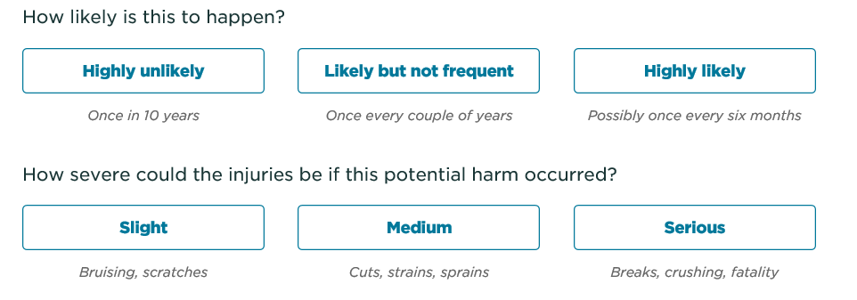
Step 2.2 Consider the proportional risk
Not all risks require the same level of attention – those with consequences that are unacceptable must be addressed.
In answering the above questions on each risk, you will identify if the risk is high, moderate or low priority. A “proportional response” requires that you pay the most attention to a risk rated high.

The below Risk Matrix classifies risk impact as:
High Risk | implement controls now
Moderate Risk | should be controlled
Low Risk | controls may not be needed or are a low priority

 | Risk Matrix | Consequence
 |  | Slight  Bruising, scratches | Medium  Cuts, strains, sprains | Serious  Breaks, crushing, fatality
Likelihood | Highly likely  Every 6 months | Moderate | High | High
 | Likely but not frequent  Every couple of years | Low | Moderate | High
 | Highly unlikely  Once in 10 years | Low | Low | Moderate

Step 3 – Control
Where a hazard is to be controlled, this must, if practicable, be by elimination.
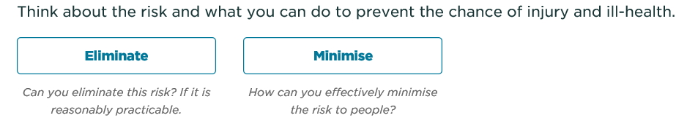
If a risk can’t be eliminated it must be minimized so far as is reasonably practicable. Risk management must be by the application of the hierarchy of controls, which MUST be considered in descending order. Not every control can be applied to every risk but in some cases more than one control will be selected for a risk (particularly at the bottom of the hierarchy).
Hierarchy of Controls
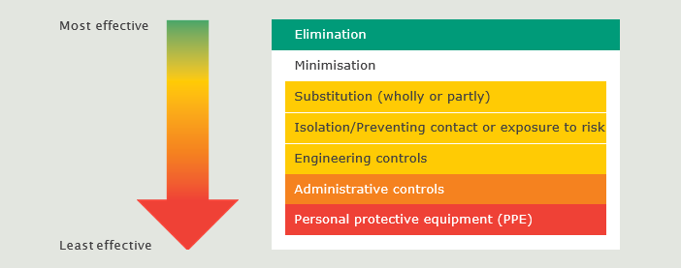

Controls should be determined considering the input of a selection of people who interact with the hazard.

Select the relevant control(s) to apply to the risk. Examples of the application of the hierarchy of control are:
ACTION |  | WHAT IS THIS? | EXAMPLES
Eliminating |  | Avoiding the sources of harm (e.g., equipment, substances or work processes) | Removing a trip hazard or getting faulty equipment repaired.  Removing the need to climb the stairs by meeting downstairs.  Deciding not to have a helicopter on display in the Showgrounds.
Minimise | Substituting | Using a less hazardous thing, substance or work practice | Using non-toxic glue instead of a toxic glue.  Relocating overhead cables underground.  N.B Take care this does not create a new risk.
 | Isolating/ preventing contact or exposure to risk | Separating people from the hazard/preventing people being exposed to the risk | Marking the hazardous area, fitting screens  or putting up safety barriers around the hazard for example:  > barriers to separate areas where horses or livestock move through the public to enter the arena or between the public and amusements.  > Keep gates on the arena closed.  > Keep livestock in pens.
 | Imposing engineering controls | Using physical control measures (e.g., mechanical devices, structural designs) | Appropriately designed, maintained, used and guarded amusements.  Designing new buildings or yards taking safety into account e.g., the gate location.
 | Imposing administrative controls | Using safe methods of work, processes or procedures designed to minimise risk | Requiring the public to keep out of the horse parking area (signage).  Having emergency plans and evacuation procedures in place.  Applying rules such as a fall results in elimination.  Food outlets have appropriate certifications.
 | Using personal protective equipment (PPE) | Using safety equipment to protect against harm. PPE acts by reducing exposure if an incident occurs | Using safety glasses, overalls, gloves, helmets, respiratory gear and earmuffs.  Riding helmets and other safety equipment.
Recording, Monitoring and Review
The hazards, risks and controls are recorded in a register and monitored for ongoing suitability and effectiveness. New control options may become available or appropriate, or controls may fail over time.
Controls must be reviewed formally at least annually prior to the show and when a high potential incident occurs.
Incident Reporting and Investigation

Policy statement
Whenever a person is or could have been harmed (or damage could have or did occur), Masterton A&P Association expects the incident to be reported. Incidents that result in injury, and near misses that could have had serious implications, should be investigated.
Purpose
To provide procedures for recording and investigating incidents, to ensure they are effectively managed, and any lessons are learnt from them.
Responsibilities
To assist Masterton A&P Association in meeting its aims in the prevention of harm, the following people have responsibilities.

The Show Manager is responsible for:
• preventing harm by providing a safe and healthy Showgrounds and show
• taking all practicable steps to see that all staff, volunteers, contractors, hirers, trade stall holders, entertainment providers and food outlets are aware of the incident reporting system, know where to obtain the appropriate form, and report such events when they occur and report incidents as appropriate to the owners of the Showgrounds
• arranging for appropriate first aid and emergency care (or other assistance) where required
• the completion of appropriate investigations of incidents that occur

Staff members and volunteers
Every staff member and volunteer are responsible for:
• observing any established health and safety procedure that relates to the activity
• participating in relevant health and safety training, e.g., manual handling, use of equipment
• accurately reporting and documenting all incidents and observed hazards

Judges, show day volunteers and officials
Specifically, judges, show day volunteers and officials shall:
• report any incident that occurs in their area of responsibility and participate in any investigations required
• manage hazards and risks in line with the Show Plan
• report any areas of safety improvement they identify
• eliminate or ask to leave any competitors who might reasonably be considered to be unsafe to continue

Competitors
Competitors shall:
• adhere to the terms and conditions of entry and all instructions and signage
• only enter exhibits they can control safely, and remove any exhibits quietly and promptly where they create an unacceptable risk to themselves or others

Public
The public are expected to obey signage and instructions from officials and report any incidents that occur.

Hirers, Contractors, trade stall holders, entertainment providers and food outlets
These parties are expected to obey signage (and instructions from officials); report any incidents that occur; consider the hazards identified to them and created by them; and implement relevant controls.
Procedures

When harm occurs
Make sure anyone injured or suspected of injury has received appropriate first aid and medical attention if necessary. Call 111 for an Ambulance if required.
If an incident may be notifiable do not interfere with the accident scene without the permission of a Work Safe Inspector.

Record of incident
All incidents are to be reported as soon as practical to Show Manager (but within 24 hours) using the Incident Report form. Copies of the form are provided to show officials.
Incident reports are filed by the Show Manager and held in the Secretary’s office.
They are reviewed by the committee at their next meeting after the incident occurred.

Notification
Work Safe must be notified when certain work-related events occur. Greater detail on the definitions and processes can be found at http://www.business.govt.nz/worksafe/notifications-forms/notifiable-events.
A notifiable event is when any of the following occurs as a result of work:
- a death - If someone has been killed as a result of work, notify Work Safe immediately on 0800 030 040 (24/7) or complete the online notification form or complete the Notifiable Death, Injury or Illness form [PDF 343KB].
- notifiable illness or injury – includes amputation; serious head injury, eye injury or burn; spinal injury; loss of bodily functions; serious lacerations; skin separation or any injury that requires (or would usually require) the person to be admitted to hospital for immediate treatment.
- a notifiable incident - an unplanned or uncontrolled incident in relation to a workplace that exposes the health and safety of workers or others to a serious risk arising from immediate or imminent exposure to any of the following:
  - a substance escaping, spilling, or leaking
  - an implosion, explosion or fire
  - gas or steam escaping
  - a pressurised substance escaping
  - electric shock (from anything that could cause a lethal shock, for example it would not include shocks due to static electricity, from extra low voltage equipment or from defibrillators used for medical reasons)
  - the fall or release from height of any plant, substance, or thing
  - damage to or collapse, overturning, failing or malfunctioning of any plant that is required to be authorised for use under regulations
  - the collapse or partial collapse of a structure
  - the collapse or failure of an excavation or any shoring supporting an excavation
  - the inrush of water, mud, or gas in workings in an underground excavation or tunnel
  - the interruption of the main system of ventilation in an underground excavation or tunnel

A notifiable incident also covers the incidents specified above which may have only resulted in minor (non-notifiable) injuries but had the potential to cause serious injury, illness or death and any injury that requires (or would usually require) the person to receive medical treatment within 48 hours of exposure to a substance.
Notifications are completed via the online notification form or complete the Notifiable Death, Injury or Illness form [PDF 343KB].

Investigations
All notifiable events and all incidents rated as “high potential” when the Risk Matrix (see Hazard and Risk Management) is applied and the worst credible scenario considered, will result in an investigation.
Investigators will be appointed by Show Manager and should have appropriate skills to enable them to identify the lessons from the incident.
In the event of an incident that results in an injury requiring emergency medical attention the Show Manager is to be advised immediately.
The Show Manager should:
• initiate and carry out an investigation. This should commence within 24 hours of the event concerned and:
- find out what happened
- identify the causes including
  - decisions, that while they made sense at the time, in hindsight contributed to the outcome
  - environmental, equipment and design factors
  - processes that didn’t work effectively
- identify and implement measures to prevent a reoccurrence
- communicate the changes to anyone who needs to know
• ensure any hazard that is identified as the cause of the event is eliminated or minimised in accordance with the hierarchy of controls
• ensure all corrective actions that have been identified are carried out within the specified timeframes
• the investigation report will be reviewed by the committee to ensure that the corrective actions have been carried out as indicated and to check, if applicable, that significant hazards have been controlled appropriately.
The reports of investigations conducted by contractors, hirers, trade stall holders, entertainment providers or food outlets will be provided to the Show Manager.

Emergency Plan

Policy
Masterton A&P Association recognises the need to be prepared for emergency situations that may be encountered.
Responsibilities

The Show Manager is responsible for:
• acting as the warden for Masterton A&P Association
• ensuring all staff and volunteers know what to do in an emergency
• maintaining emergency supplies of water and provisions in accordance with civil defence recommendations
• maintaining a register of anyone who may require special assistance in the case of an emergency requiring evacuation

All staff, volunteers, trade stall holders, entertainment providers and food outlets are responsible for:
• maintaining familiarity with emergency responses and following procedures
• advising the Show Manager of any special assistance that may be required in case of an emergency requiring evacuation (e.g., in case of deafness, physical disability)
• ensuring their own safety if working alone

Hirers and contractors are responsible for:
• ensuring they have a site warden
• ensuring all their people are familiar with emergency responses
• following these procedures or implementing their own that apply to emergencies specific to their use of or work on the Showgrounds
Procedures

1. When emergency services are required
• For emergency services dial 111 and ask for the service you require:
FIRE
AMBULANCE (Noting that on show day first aid support is available from the Ambulance located near the Secretary’s office.
POLICE
• Stay calm, give your name, details of the emergency and street address - which is
Solway Showgrounds, Corner Fleet and Judd Streets, Masterton
PHONE NUMBER 06 378 6247
• The public and visitors
On show day first aid support is available from the Ambulance located near the Secretary’s office
Other public assistance is available from the Secretary’s office.
Visitors are the responsibility of the person they have called to see.

2. Fire
If you discover a fire:
• activate the alarm and dial 111 and advise a Masterton A&P Association official
• alert people in your area and the warden (the Show Manager is the warden) or a health and safety representative in his/her absence
• do not extinguish the fire unless there is no personal danger to you or anyone else
• if time permits and there is no danger, close all doors and windows
• evacuate the building following the evacuation procedure
• after evacuation meet at the assembly point

3. Earthquake
• move away from windows, equipment, shelves and trees that may fall
• if inside, take cover under solid furniture such as tables and desks
• do not try to evacuate until the shaking has stopped
• be prepared for aftershocks
When the shaking stops:
• keep calm and help those who need assistance
• wait for orders from your warden
• check for hazards and extinguish any fires if safe to do so
• evacuate buildings if instructed to do so
• listen to the radio for civil defence instructions
• ensure the electrical power supply is turned off at the mains supply to the show – use only generator power
• during a show or event close down all activities starting with amusement devices and children’s activities
• during a show or event, it may be appropriate to evacuate all people to designated safe areas (likely to include the carpark) e.g., from temporary structures and dangerous areas such as hot food appliances and electrically operated equipment
• secure animals

4. Flood (Natural Disaster)
• shut off the power and water and turn off electrical appliances if there is no personal danger in doing so
• move vital records to highest accessible point if safe to do so
• notify emergency services

5. Unwanted or aggressive person
• keep calm, make no sudden movements - try to avoid escalation
• if you have an opportunity to do so, have another person with you or discretely get someone’s attention
• try to memorise as many details about the person and the interaction as possible
• notify police as soon as it is safe to do so - leave the phone line open until police arrive

6. Bomb threat
When a bomb threat is received, or a suspicious object is discovered, it must be treated as genuine until proven otherwise.
Do not touch or move any suspicious object. Treat unusual or suspicious objects as a bomb, as they can be made to resemble almost anything. The Police will determine the action to take with the object.
• keep calm
• keep the person talking – don’t interrupt
• let them feel in charge – keep the person on the line, don’t hang up
• do not operate the manual alarm points or electrical switches, or use a mobile telephone
• attract assistance if possible and have this person alert staff and notify Police on 111
• evacuate the building if directed to do so by the Police (but do not hang the phone up on the caller)

7. Chemical spill or explosion

Contact the Show Manager who will contact emergency services and activate emergency evacuation procedures as necessary.

8. Animal escape or out of control
• ask the competitor to remove an unsafe animal
• close boundary, arena or other gates - try to contain the animal if possible, without putting people at risk
• consider animal control options
• evacuate relevant areas and consider public safety and vulnerable competitors e.g., first ridden exhibitors
• only experienced handlers attempt capture
Evacuation Procedures
If the fire alarm sounds:
• walk quickly to your nearest exit
• make sure any visitors leave the building with you
• do not stop to take personal items with you
• keep to the left of the stairs
• meet at the assembly areas at either the upper Judd Road gate and/or the York/Fleet gate specify and report to the warden.
Warden
• the warden has responsibility for the site until the emergency services arrive
• must understand the emergency evacuation procedures and lead trials and actual evacuations
• determines that an evacuation is required (if an alarm does not sound) and may need to sound the alarm
• ensure all persons have evacuated the buildings and/or Showgrounds
• undertake drills regularly e.g., at least once every 12 months
• call and co-ordinate with the emergency services
If you need to evacuate the Showgrounds:
• contact the Masterton A&P Association office for public sound system messages and emergency service involvement
• advise all persons to make their way to the car park area if this is not the source of the harm
• walk quickly to your nearest exit
• make sure any visitors leave the building with you
• proceed in an orderly manner out of the building by the nearest doorway
• provide a copy of the Hazard Map to show the location of chemicals, fuels, equipment and utilities to the emergency services

Participation and Leadership

Policy statement
Masterton A&P Association recognises that to achieve good safety outcomes, the people doing the tasks should be consulted about the safety of those tasks. They also recognise the need for leadership in health and safety.
Everyone is encouraged to actively participate in health and safety discussions and meetings.
Where changes to existing policies are being considered staff, volunteers and relevant contractors (and regular hirers) will be invited to comment and participate in the consultation process prior to implementation of changes.
Purpose
To ensure that everyone relevant has an opportunity to be included in safety decisions.
Leadership
Masterton A&P Association identify a committee member to champion and co-ordinate health and safety activities. This does not take responsibility from the committee overall or the Show Manager but enables others to seek their support on relevant matters and to co-ordinate meetings, solutions and investigations.
Responsibilities

The Show Manager is responsible for ensuring that:
• everyone who does or is affected by a specific activity e.g., the management of livestock, has the opportunity to be heard in relation to safety related decisions affecting that activity
• ensuring that health and safety matters are regularly discussed at meetings, including the committee meeting, where it should be a standing agenda item.
• changes that affect staff or volunteers are discussed with them and decisions are communicated to them
• The health and safety manual will be reviewed two-yearly by the Show Manager in consultation with the Health and Safety Committee including staff, volunteers and relevant contractors.

Staff, contractors, hirers, trade stall holders, entertainment providers, food outlets and volunteers are responsible for:
• speaking up about their health and safety concerns
• participating in discussions and help find solutions for health and safety issues that affect them
• requesting the formation of a health and safety committee if they see a need for it (staff and volunteers only)

Health and Safety Committee Meetings
If it is requested, a health and safety committee is formed to regularly discuss health and safety matters.

Health and Safety Committee Meetings
• Health and Safety Committee meetings are held at least twice per year (up to quarterly), including one shortly before the Show and another shortly after.
• All staff and volunteers are invited to participate
• Meetings agendas will cover hazards and risks; incidents and investigations; any proposed structural additions to the grounds or equipment purchases; and any upcoming or recently held events.
• An extraordinary meeting will be held in the event of a notifiable event being investigated.
Review and Audit

Policy statement
Masterton A&P Association will regularly review and audit their policies, procedures, hazards, risk and incidents. It will organise itself in a manner to ensure all these activities are undertaken appropriately.
Purpose
To ensure that:
• all the policies and procedures remain effective, implemented and relevant
• hazards and risks are identified, appropriately managed and monitored
• incidents and near misses that occur are reviewed and the lessons they offer are learnt and applied
Responsibilities

The Show Manager is responsible for ensuring that:
• the health and safety manual are applied as a living, useful document
• this health and safety manual is reviewed annually (prior to the show) and improvements that are identified are made
• a post-show review is conducted and any new hazards and risks that came to light are noted; any ineffective hazard and risk controls revised; and any incidents reported are reviewed. In all cases any learnings from the show are captured and recorded for improvement at the next show
• incidents and near misses are reported and investigated where appropriate

Staff and volunteers are responsible for:
• continually considering practical, safer ways to achieve results
• identifying new hazards and risks (and controls) and ensuring they are reported
• reporting incidents and near misses that occur and suggest improvements
• co-operating with reviews and audits

Committee responsibilities:
• the Showgrounds are safe for all people that use them, and the show is run in a manner that limits the hazards and risks that attendees are exposed to
• commissioning reviews and audits

Show/Event Plan

Policy statement
Prior to any Show or Event held by Masterton A&P Association a health and safety Show Plan (or Event Plan) for that competition will be developed which will be applied.
Purpose
To ensure that:
• all hazards and risks are identified, appropriately managed and monitored (including new ones relating to specific competitions, trade stalls, entertainments, food outlets or expected weather conditions)
• the preparation, running and disassembly of the competition are all considered
Responsibilities

The Show Manager is responsible for ensuring that:
• the Showground layout, including identified hazards and risks, are reviewed in consideration to the show or event planned and any changes that may have been made or occurred to the Showgrounds
• a Show or Event Plan is developed, taking into account fixed hazards (present at all times) and introduced hazards (only present for a specified period or created by the competition held)
• reviewing the effectiveness of the plan after the show or event
• appropriate first aid providers are on the Showgrounds for the show or event and veterinary assistance identified

Staff and volunteers are responsible for:
• abiding by the show plan and reporting any issues they experience that indicate changes are needed or improvements possible

Information, Training and Supervision

Policy statement
Masterton A&P Association recognises their responsibility to promote a safe and healthy show and Showgrounds. Everyone needs to actively participate in health and safety and requires information, training and supervision to support safe practices.
Purpose
To ensure that everyone is provided with adequate information, training and supervision on health and safety matters.
Responsibilities

The Show Manager is responsible for ensuring that all newly appointed staff and volunteers receive:
• an induction to health and safety on site
• any additional training that is required as a result of specific activities they undertake
• any protective clothing or equipment required for the tasks
• adequate supervision to ensure a safe environment

The Show Manager is responsible for ensuring that staff and volunteers receive:
• opportunities to contribute to health and safety improvements, meetings and discussions
• an opportunity to receive appropriate training relevant to the tasks they do
• copies of relevant material safety data sheets for chemicals they use
• vehicles and equipment that are suitable, safe and well maintained – and training in their use
• any relevant health monitoring

Staff and volunteers are responsible for:
• following instructions where provided, including the use of plant, equipment and personal protective equipment
• completing the induction process including reading the health and safety manual and undertaking training as directed
• reporting and co-operating with the management and monitoring of hazards and risks
• using and caring for protective equipment or clothing provided
• reporting incidents and near misses, including those that result in injuries or ill health
• not undertaking work that is unsafe
• not interfering with an accident scene
• driving to the speed limits and conditions, including on Showgrounds and wearing provided seatbelts
• undertaking any relevant health monitoring as directed

Hirer, contractor, trade stall holder, entertainment provider and food outlets are responsible for:
• ensure only people with the appropriate skills, instructions, supervision and personal protective equipment operate equipment and undertake tasks

Contractors, Visitors and Other Persons

Policy statement
Masterton A&P Association is firmly committed to the provision of a safe and healthy workplace for all, including contractors, visitors, hirers, trade stall holders, entertainment providers and food outlets. Masterton A&P Association seeks to:
• ensure that everyone on the Showgrounds is able to work in a healthy and safe manner and is not harmed (and does not cause harm to others) while working
• promote measures to prevent injury and illness by insisting on safe methods, safe equipment, proper materials and safe practices at all times
• ensure that visitors and the public are not harmed while on Masterton A&P Association premises.
Responsibilities

The Show Manager is responsible for:
• ensuring details of any specific hazards that may be relevant them is provided to contractors, visitors and other persons. This may include a Hazard Map.
• advising the contractor and relevant other persons on miscellaneous matters, such as how to activate the fire alarm, the location of fire extinguishers and first aid assistance and where and to whom they should report in case of an emergency situation or an incident
• advising visitors of any hazards and evacuation procedures in case of an emergency and of the policy that they must be escorted at all times
• maintaining a record of visitors and contractors on the premises and ensuring all contractors have the appropriate health and safety processes; equipment (including personal protective equipment); skills and supervision
• ensuring visitors are escorted at all times
• ensuring appropriate signage and show set up to provide a safe Showgrounds for all
• ensuring the Showgrounds are in a safe condition for hirers and the purposes for which it is hired.

The contractor or other person is responsible for:
• providing details of any hazards that they will be bringing onto the site or any hazards that may be created as a result of the nature of the work being undertaken, together with how these hazards will be mitigated
• ensuring their people have received the safety training required for the specific job, including protocols for entry to restricted areas
• providing and using emergency and personal protective equipment they may require
• taking all practicable steps to ensure they do not harm any person
• submit a health and safety plan before any contract is accepted

The visitor is responsible for:
• acting on the instruction of the Show Manager (or other nominated health and safety representative) in the case of an emergency
• advising the Show Manager of any special assistance that may be required in case of an emergency requiring evacuation.

Smoke-Free Working Environment

Policy statement
It is a requirement of the Smoke-free Environments Act 1990 that all employers have a written policy on smoking for all areas occupied by the employer and frequented by employees.
Purpose
This policy meets the requirements of the Smoke-free Environments Act 1990 and the Smoke-free Amendment Act 2003 and is based on the following principles:
1. Everyone is entitled to a smoke-free environment in all the areas normally used for work.
2. Everyone who does not smoke, or who does not wish to smoke in their place of work, must, as far as is reasonably practicable, be protected from tobacco smoke in their place of work.
3. The implementation of this policy depends on everyone responding courteously to the desire for a smoke-free environment.
Procedure

Smoke-free buildings:
Smoking in buildings is prohibited as it endangers the safety of others, creates an unhealthy environment and causes damage to property.
In the event that an employee chooses to smoke, a designated area, such as a sheltered balcony outside of the premises, should be used.
Passive smoking:
Smoking is permitted in outside areas, provided others are protected from smoke drift and passive smoking by the smoker keeping their distance from people, and opening windows and doors within their close proximity.

Complaints:
Complaints regarding smoking and suggestions or complaints regarding a smoke-free environment should be brought to the attention of the Show Manager.

First Aid

Policy statement
Masterton A&P Association has a responsibility to take ‘all practicable steps’ in providing effective first aid arrangements at all times when people are using the grounds for any authorised purpose.
Purpose
To ensure safe and consistent care is taken when first aid may be required.
Responsibilities

The Show Manager is responsible for:
• ensuring appropriate first aid supplies are provided at the Masterton A&P Association office and as appropriate to the public and competitors on show day
• ensuring that first aid supplies are accessible at the office
• ensuring an incident register is completed in the event that first aid is rendered
Minimum contents for office First Aid Kit
• A manual giving general guidance on first aid
• 20 individually wrapped sterile adhesive dressings (various sizes), appropriate to the type of work
• 2 sterile eye pads
• 2 individually wrapped triangular bandages
• 6 safety pins
• 6 medium-sized, individually wrapped sterile unmedicated wound dressings, about 12 cm x 12 cm
• 2 large sterile individually wrapped unmedicated wound dressings, approximately 18 cm x 18 cm
• 1 pair of disposable gloves
• 1 resuscitation mask
Note: Pain relief should not be included in first aid kits. Special provision for treating allergic reactions should be the responsibility of the person with the allergy.

